SEC Cyber Rules Compliance for Log360
Strengthen cybersecurity and meet SEC Cyber Rules compliance with Log360.
Region: USA | Type: General Compliance | Category: Compliance | Pricing: Free

Overview
The SEC Cyber Rules compliance extension in Log360 helps organizations meet the SEC Cybersecurity Risk Management, Strategy, Governance, and Incident Disclosure Rules, issued by the U.S. Securities and Exchange Commission for publicly traded companies by providing centralized log management, real-time threat detection, and comprehensive audit trail generation. The platform supports SEC Cyber Rules requirements for cybersecurity incident detection and disclosure, access control oversight, privileged account monitoring, network perimeter security, audit logging, and third-party risk visibility.
For Cybersecurity Incident Detection and Monitoring, Log360 provides real-time threat detection via correlated log analysis, behavioral analytics, and automated alerting across endpoints, network devices, and cloud environments. To address Incident Disclosure and Audit Evidence, the platform centralizes security incident logs, system events, and backup malware detection records to support timely and accurate regulatory disclosures. The extension also supports Access Control and Identity Governance by providing capabilities that monitors user authentication, failed logon attempts, Active Directory access patterns, and remote desktop sessions to demonstrate identity governance controls over critical systems.

Key Features
- Privileged Access and User Management: Log360 tracks administrative account changes, user group modifications, SUDO command usage, password policy enforcement, and privilege escalation events across Windows, Unix.
- Network Security and Perimeter Monitoring: Log360 captures firewall events, network device configuration changes, rule management activity.
- Audit Logging and Compliance Records: Log360 centralizes Windows event logs, Active Directory audit trails, GPO changes, process tracking, and computer auditing records to create a comprehensive forensic record for regulatory evidence.
- Third-Party and Cloud Risk Monitoring: Log360 monitors cloud storage access, AWS IAM activity, unauthorized cloud actions, and third-party integration events to identify and evidence supply chain security risks.
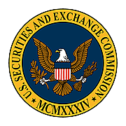
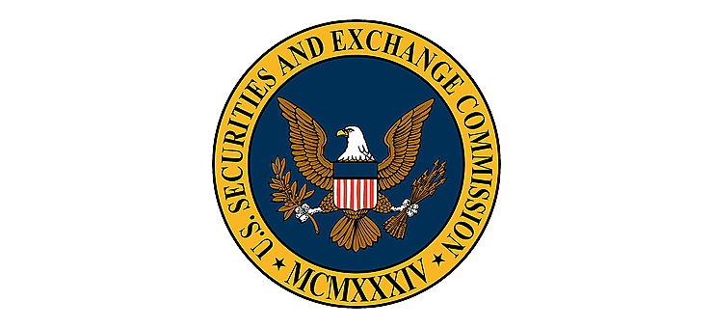
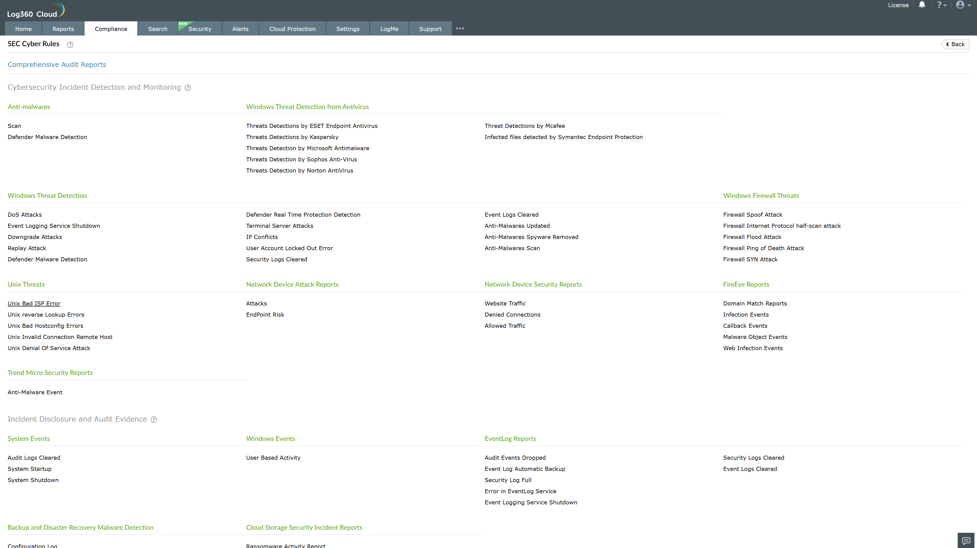
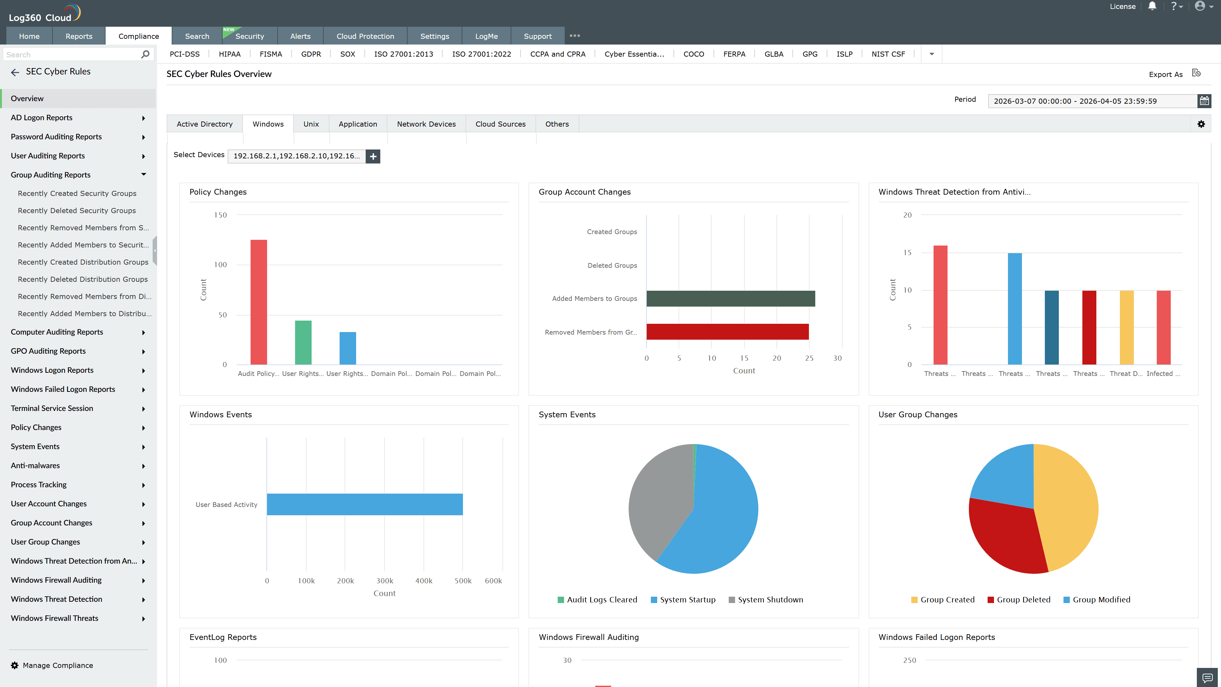
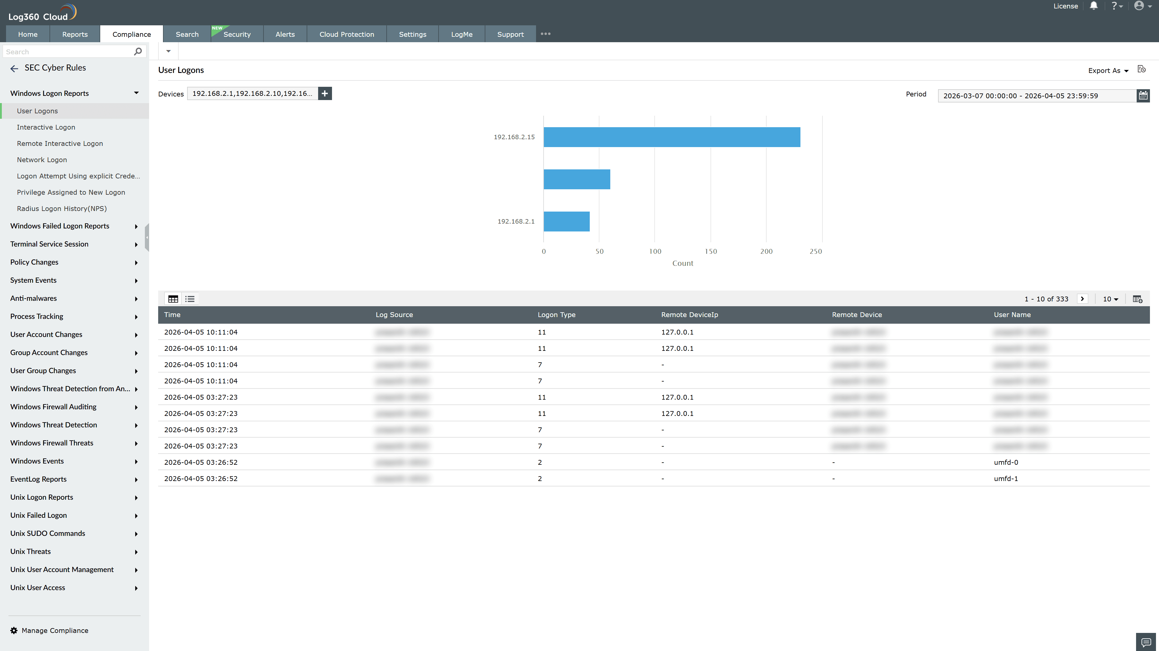
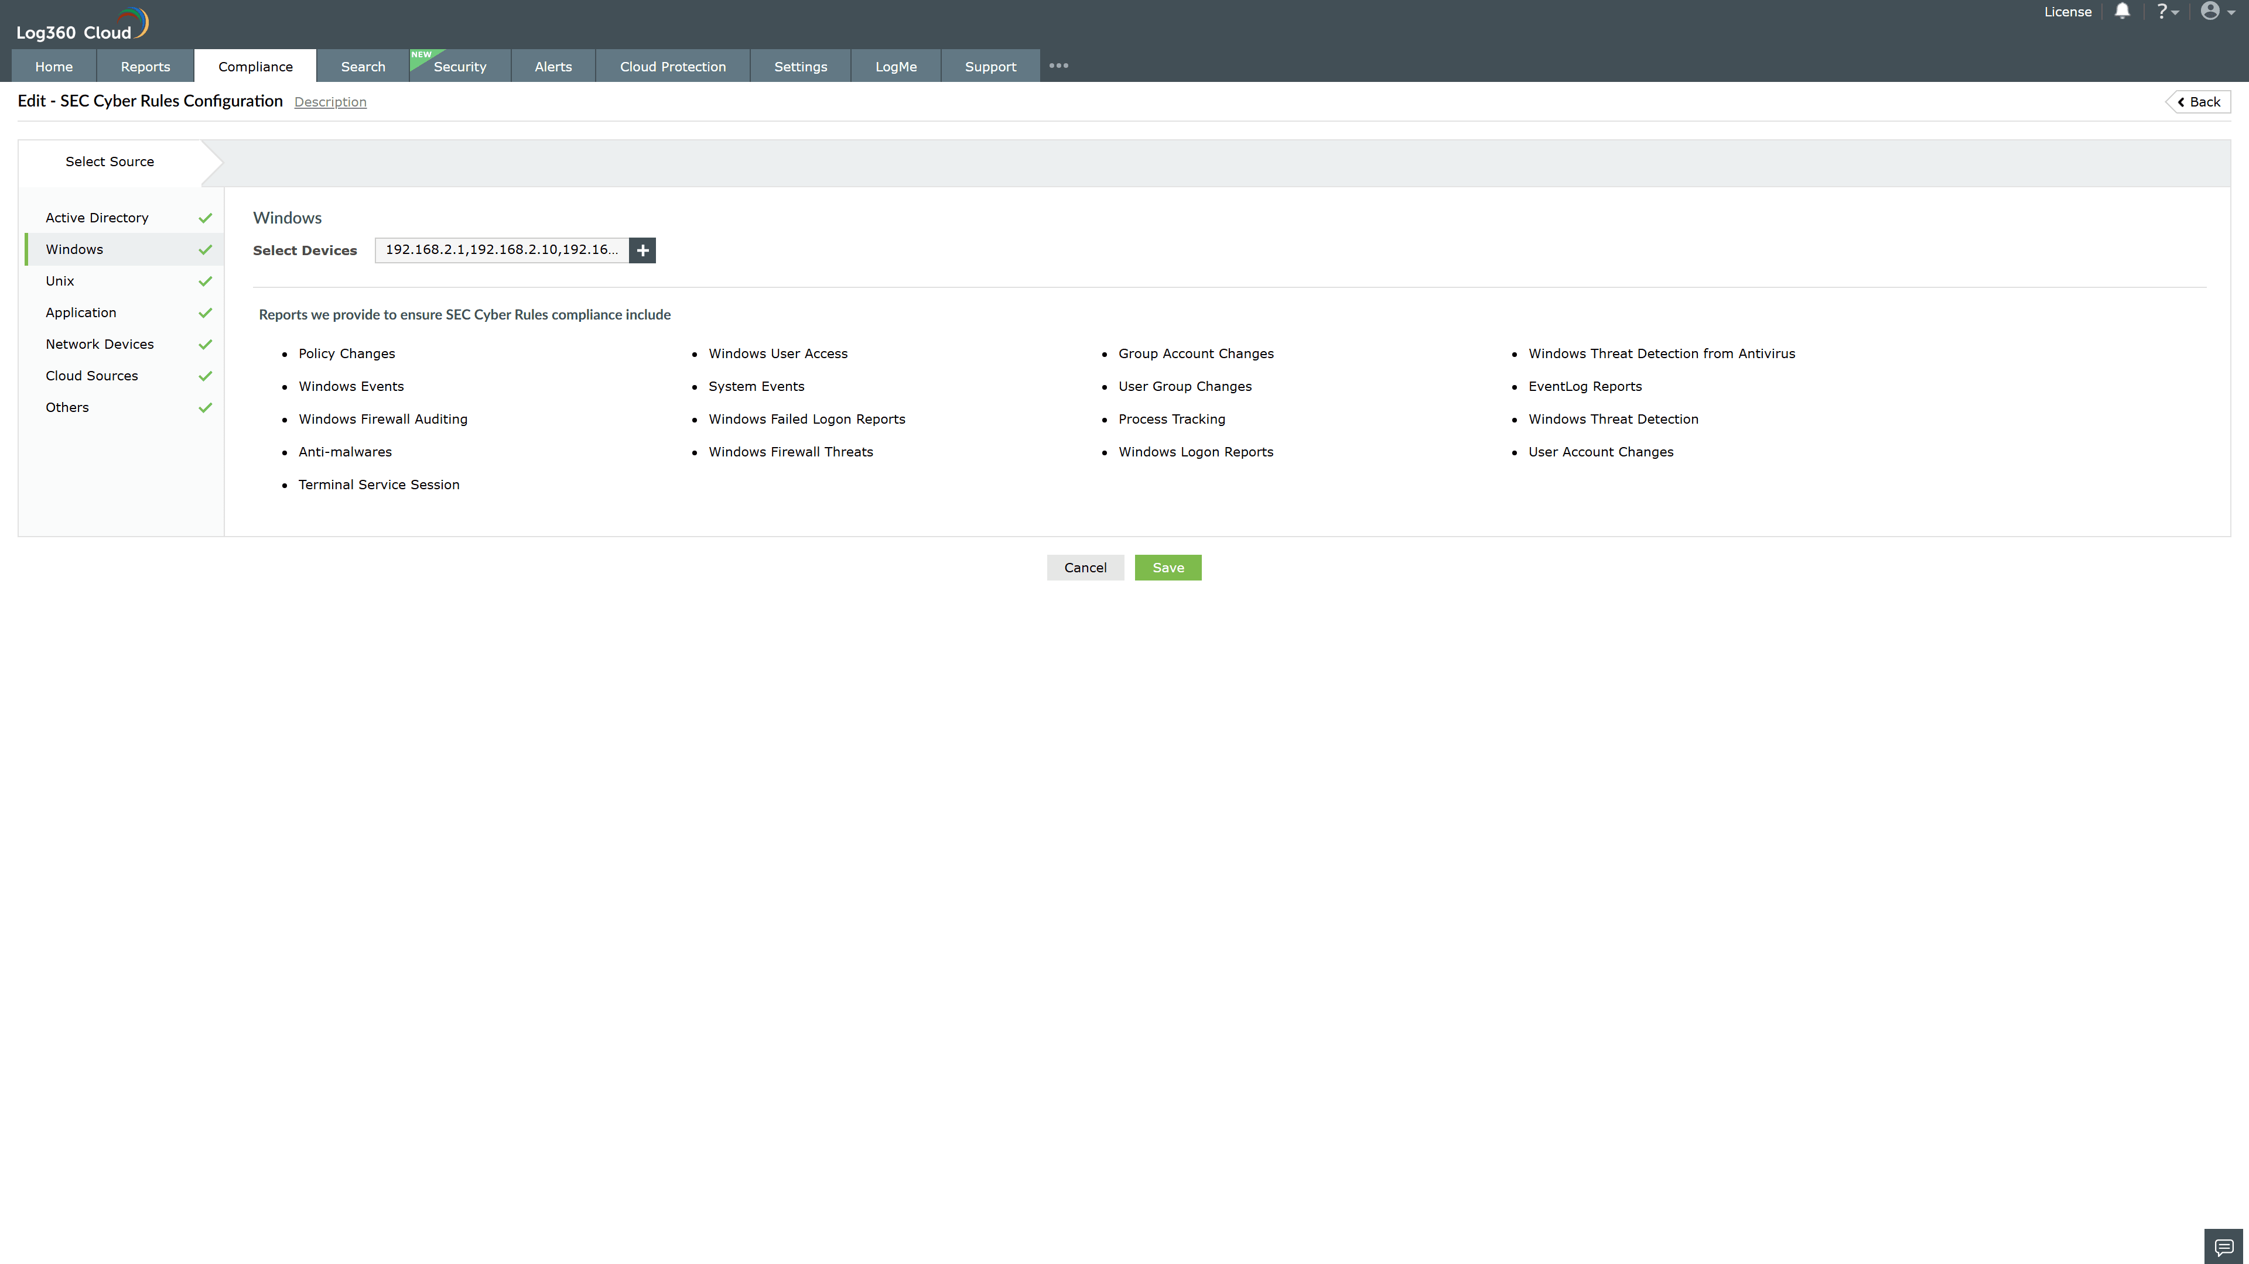
Valid Submission : Yes
Supported Editions : Free, Basic, Standard, Professional, MSSP
Help Document : https://www.manageengine.com/log-management/help/integrations/compliance-extensions.html
Help Video : Not provided
Tags : Log360, Compliance, Privacy monitoring, Data privacy, Regulatory compliance
Supported DCs : US, IN, JP, CA, AU, UK and EU
Privacy Policy:
Terms of Service:
Release Notes:
Predefined reports for the SEC Cyber Rules.

